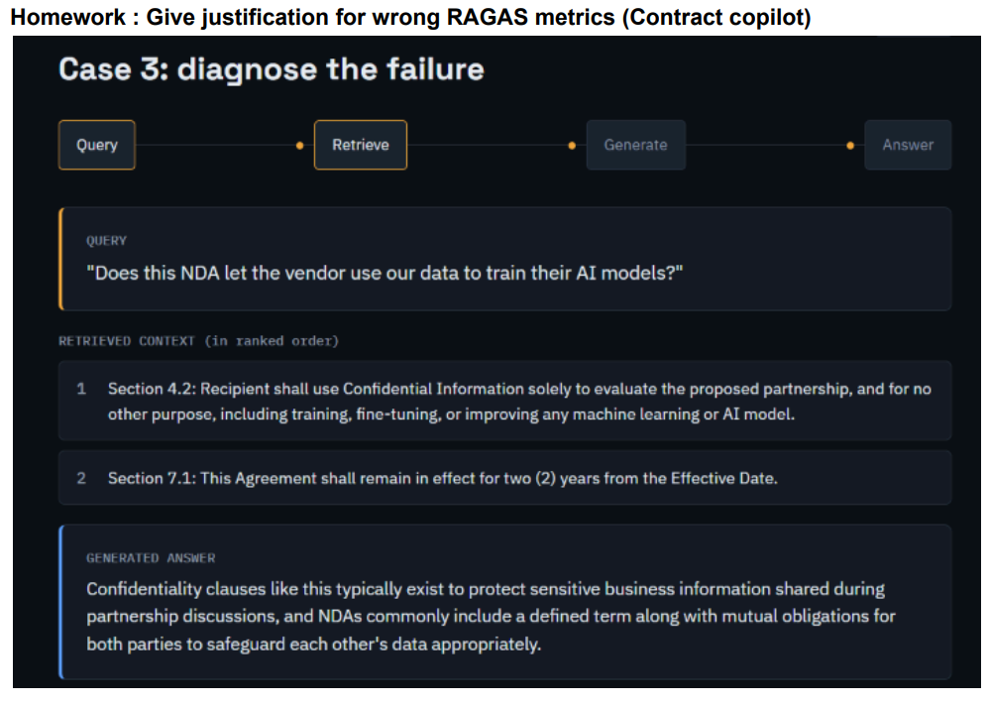

Answer Relevance: The generated answer completely ignores this specific question about AI model training permissions.

